

**PROPOSAL:**

**LANGUAGE TRANSLATION**

**APPLICATION**

**MOHAMMAD AL BAWARIDY**

**Submitted by**

Mohi Karim

Verbanet Technologies LLC  
12.03.19

**DIRECTORY.**

**1 KEY DETAILS 5**

**2 STRATERGIC OBJECTIVES 6**

**3 PROJECT SCOPE 7**

3.1 PROPOSED SOLUTION MODEL 7

3.2 FUNCTIONAL REQUIREMENTS 8

**3.2.1 User Registration 8**

**3.2.2 Communication Options 9**

**3.2.3 Message Encryption 9**

**3.2.4 Call Metering 9**

**3.2.5 Access to contacts 9**

**3.2.6 Sharing and Rating 9**

**3.2.7 App Permissions 9**

**3.2.8 Payment Processing 10**

**3.2.9 Google Ads 10**

**3.2.10 Application and User Preferences 10**

**3.2.11 General Information 10**

**3.2.12 Make New Voice Call 10**

**3.2.13 Create New Text Message 11**

**3.2.14 Admin Panel 11**

**3.2.15 How to Earn Free Minutes 12**

**3.2.16 How to Buy Credit 12**

**4 APPLICATION ARCHITECHURE 13**

4.1 MESSAGE SEQUENCE SAMPLE 13

4.2 GOOGLE SPEECH SERVICES 15

**4.2.1 Conceptual View of the Implementation 15**

4.3 OPERATIONAL COST CONSIDERATIONS 18

4.4 USING FIREBASE AS THE BACKBONE 19

4.5 NON-FUNCTIONAL REQUIREMENTS (OTHERS) 20

4.6 TECHNICAL CONFIGURATIONS 20

**4.6.1 DEVELOPMENT ENVIRONMENT 20**

**4.6.2 RECOMMENDED WED HOSTING PACKAGE - DEDICATED 21**

**4.6.3 BROWSER 21**

**4.6.4 HARDWARE DEVICES 21**

**4.6.5 TECHNICAL STANDARDS 22**

**4.6.6 TECHNICAL GUIDELINES 22**

4.7 PROJECT DELIVERY 23

**4.7.1 PROJECT MANAGEMENT 23**

**4.7.2 ROLES & RESPONSIBILITIES 23**

**4.7.3 DELIVERY ACTIVITY SUMMARY 24**

**4.7.4 PROJECT IMPLEMENTATION PLAN 25**

**4.7.5 DELIVERABLES 25**

**4.7.6 ESTIMATED DELIVERY TIME 26**

**4.7.7 DEPLOYMENT DETAILS 28**

**4.7.8 RELEASE PLANNING 28**

**4.7.9 RISK CONTINGENCY PLANNING 28**

4.8 PROJECT ASSUMPTIONS 30

**4.8.1 OBJECTIVES 30**

**4.8.2 DESIGN 30**

**4.8.3 DEVELOPMENT 30**

**5 OUT OF SCOPE 31**

**6 CHANGE MANAGEMENT 33**

6.1 MAINTENANCE & SUPPORT 34

**7 TERMS AND CONDITIONS 35**

7.1 ACCEPTANCE CRITERIA 35

7.2 WARRANTY 35

7.3 SOURCE CODE & INTELLECTUAL PROPERTY RIGHTS 36

7.4 GENERAL TERMS AND CONDITIONS 36

7.5 GENERAL ADMINISTRATIVE,TECHNICAL & FUNCTIONAL ASSUMPTIONS 38

**8 FINANCIALS 39**

8.1 LANGUAGE TRANSLATION APPLICATION 39

8.2 PAYMENT TERMS 39

**8.2.1 MODE OF PAYMENT 40**

# **KEY DETAILS**

**PROJECT NAME CLIENT**

Language Translation Application Mohammad Al Bawaridy

**CLIENT CONTACT PROPOSAL ID NO.**

Mohammad Al Bawaridy AD/BP/12032019/2609/1

m.aldarabee@gmail.com

+966 59 011 1298

**PROPOSAL SUBMISSION ANTICIPATED START DATE**

12.03.19  TBD

**PROPOSAL VALID UNTIL PROPOSED TECHNOLOGY**

11.04.19 Node JS, Google Fire Base

Google Cloud Product

Hybrid Mobile

**PROPOSAL SUBMITTED BY APPLICATION TYPE**

Mohi Karim Web & Mobile Application

Verbanet Technologies L.L.C

Dubai, U.A.E

+971 4 297 3236

Mohi.karim@verbat.com

# **STRATERGIC OBJECTIVES**

Verbat shall develop a mobile application that will translate speech from one language to another in real time*. Current voice translation services are limited to text translation services. Verbat shall develop a mobile app for the client that will translate speech in real time using Leading Edge technologies.

The mobile app shall have a friendly user interface that shall be intuitive, fast and accurate. It shall achieve this by using the following services:

* Transcribing services
* Translation services

Verbat shall develop API services which will facilitate these.

*Note:*

*\*This is contingent upon the language translation capabilities offered by Google. If Google Cloud Speech Services lacks the capability to provide the said services for a language pair, then Verbat may not be able to provide the service either partially or fully.*

# **PROJECT SCOPE**

Verbanet Technologies L.L.C., (hereafter referred under its trade / brand name as” Verbat”) in partnership with Mr. Mohammad Al Bawaridy (the Client) shall develop a mobile application that shall enable translated speech in two languages. The user of the application shall select the language that they wish to speak in. The counterpart shall select the language in which they wish to speak. For example: when the user-A has selected “English” and speaks in English, his counterpart, user-B may have selected “German”. The counterpart B shall receive the message in German and respond in German. The user-A correspondingly shall receive the message in English. The application shall be developed in multiple phases. Phase One (01) of the development shall focus on a Minimum Viable Product (MVP).

## PROPOSED SOLUTION MODEL

Verbat will be following a stand–alone fixed bid solution delivery model wherein the required solution for Phase One would be devised. Verbat’s solution architects have conducted a thorough research on the requirements and have come to the conclusion that our proposed solution, which is detailed further in this document, will meet the requirements put forth by the client.

**Key Strengths of Our Solution**

* Strong and Scalable platform accommodating to future enhancements.
* A framework which acts as a solution accelerator with building blocks that can be re-used in the future for building new components and features.
* Our light weight framework consumes fewer system resources thereby making the application perform faster.

## FUNCTIONAL REQUIREMENTS

The main stakeholders of this application are:

* Admin (Web Application): Responsible for managing the day to day activities related to overall administration of the application
* Application Users (Mobile Application): Caller / Receiver who will be able to download the application from the mobile store of choice. They shall use the application to communicate with other users.

The main features and functionalities of the application to be developed are presented below:

### User Registration

When the user downloads the application, they shall be prompted to:

* Enter their mobile number.
* The user shall receive a confirmation code.
* If the user does not receive a confirmation code in 2 minutes, they have the option to request for a new confirmation code.
* Once the confirmation code is entered, the user is a registered user of the app.
* Select their preferred language for communication.
* The application shall detect the geographic location of the user *(implies access to GPS)*
* Users can have the option of receiving certain free minutes of translated calls and free

translated text messages.

### Communication Options

The user shall have the following communication options:

* Voice calls *(implies access to mic)*
* Text messages
* Voice messages
* Share attachments *(messages, images and video: implies access to image gallery and storage)*

### Message Encryption

All messages exchanged between users shall be encrypted for security.

### Call Metering

Optionally users shall have free calls as well as paid calls.

### Access to contacts

The application shall request access to the contacts in the user’s mobile directory. Once synchronized, it shall update the status of the users who have already downloaded the application. The app shall also indicate the country flag.

### Sharing and Rating

Users shall be able to share the app with friends and rate the app.

### App Permissions

The App will request the following permissions from the user.

* Microphone permission.
* Camera permission.
* Location permission.
* Sync contact permission.
* Push notifications.

### Payment Processing

The application shall support payment process using:

* Credit Cards
* Apple Pay

### Google Ads

The app should support the display of Google Ad services. The admin shall be able to enable or disable these services.

### Application and User Preferences

The app shall allow the user to

* Set their preferences
* Edit their profile
* Change the preferences for the App

### General Information

The application shall contain generic information such as:

* Privacy policy
* About Us
* Call log information

### Make New Voice Call

To make a new voice call, the user shall:

* Select the contact or search for the contact.
* A pop up shall prompt the user to determine if it is a regular call or a translated call.
* The application shall dial the contact after selection.
* When connected, a timer shall start with a clear indication of the time elapsed along with the call cost.
* If it is a non-translated call, the app shall make a call using a third-party service.
* If it is a translated call,
  + the app shall transcribe the voice into text.
  + Convert the text from one language to another.
  + Convert the text to speech and relay it to the receiver.
* Since translation services require the coordination of multiple activities, it may not function like a regular voice call, instead it may need to function like an intercom.
* Both the receiver and the sender may need to a press a button while they are conversing. When they are done talking, they shall release the button.
* All conversations shall be encrypted and logged for security.

### Create New Text Message

Users may choose from their contacts to send text messages. User shall have the option to send plain text or have it translated to another language. User shall have the following options:

* The message must display in both sender and receiver in 2 languages, which is the original and the “translated to”, the preferred language must be in big size and the other language in small size in the below.
* Message status indicator must display for the messages (sent, delivered, read).
* Sender setting page must display capabilities which allow the user to make some actions like (Mute this sender, add to favorite ... etc.)
* The users must be able to send attachments (Images, Audio, video).
* Search field must be added to allow for the user to search in any text inside the message body.

### Admin Panel

After logging in, the admin shall have the following options

* Admin User management module.
* Push notification module: may be send by Gender, Country or all users. It may be sent immediately or it could be scheduled.
* Reports module: Reports should contain information on total downloads, Total number of brought credit, Total number of downloads by country.
* Application user’s management module must contain a list of active users.
* Admin can configure the certain minutes for free text and free calls.

### How to Earn Free Minutes

The following rules apply:

* New registered users shall have 5 minutes of translated calls and 10 text messages.
* Whenever the app is shared and downloaded, the user shall receive 2-minute calls and 4 text messages.
* For every advertisement video watched, user shall receive 2-minute video calls and 2 text messages.

### How to Buy Credit

The users must be able to buy credit by using the payment gateway in the app through fixed packages as below:

|  |  |  |
| --- | --- | --- |
| Package | Calling minutes | Text messages |
| $1 | 20 | 40 |
| $2 | 45 | 90 |
| $5 | 150 | 300 |

# APPLICATION ARCHITECHURE

## MESSAGE SEQUENCE SAMPLE

Verbat shall use a real-time messaging platform called Mesibo for direct peer to peer audio calls or messaging that does not involve translation services. Mesibo is a proprietary platform that allows one to quickly develop applications with real-time messaging, voice and video calls.

Mesibo is a high performance, high-availability, asynchronous real-time messaging platform that allows users (endpoints) to communicate with each other in real-time. Unlike other platforms, Mesibo is entirely written in C++ with state-of-the-art architecture and reliability providing unlimited scalability from day one.

Mesibo makes it extremely simple to enable real-time communication between the users. All you have to do is:

* Let Mesibo know about every user in the system. Mesibo will create an access token for each user and pass it back using Mesibo Server-side Admin API.
* These tokens are then distributed to the users.
* Users use this access token to create a real-time connection with the server to send and receive real-time messages, voice and video calls.

A more elaborate real-life scenario highlighted below in which Alice and Bob register with the backend server; here each gets real-time access token from Mesibo and starts communication in real-time.

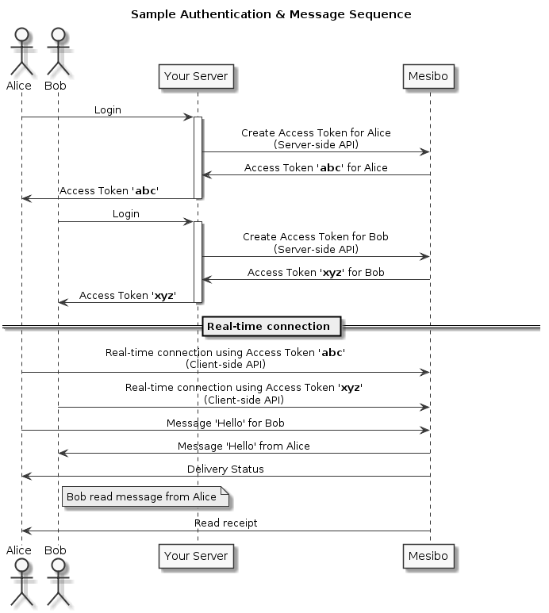

Chat Server

Chat Server

This API makes it extremely convenient and simple to send and receive arbitrary real-time messages by using well thought-of design patterns. In short:

* To send a message, invoke one of the messaging APIs. Once you specify the destination (a user or a group), type of message, expiry if any, and your message, the API will send message and also inform about the status of messages sent in real-time.
* To receive messages, implement listeners (delegates in iOS), the API will inform the peer whenever you receive any messages or calls.
* Sending and receiving files can be implemented using the file transfer handler which will upload (to send) and download (on receive) files to or from your server (between peers).

The service delivers messages instantly if the destination user is online. If not, the messages will be delivered as soon as destination user comes online. This is automatic and transparent to applications, so applications sending messages do not need to worry if the receiving applications are up and running. Conversely, receiving applications do not need to worry about the status of sending application.

*Note:*

*In this proposal, Verbat has chosen Mesibo as an example to showcase the viability of the technology and its use case. Verbat may also choose a similar third-party service like SendBird or Twilio.*

## GOOGLE SPEECH SERVICES

While the Real-Time Messaging Platform (E.g. Mesibo) is the backbone of the Speech Translation App, Verbat shall build hooks into the endpoint. These hooks become activated only when the user requests for the translation service. In normal circumstances however, the messages are relayed directly between the peers.

### Conceptual View of the Implementation

A micro service will be deployed on Google Cloud App engine using google cloud functions for Firebase. The service shall receive an input audio message and then shall translate the message to the predefined language and store the translated message into an audio file. The client app downloads and plays the translated audio files at the user’s request.

The service uses the following Google Cloud AI products to translate the message:

* Cloud Speech-to-Text
* Cloud Translation
* Cloud Text-to-Speech

The micro service stores translated audio messages in a bucket in Cloud Storage for Firebase.

#### Client App

The client component is an Android/IOS app that records audio messages and downloads the translated messages from the Cloud Storage bucket.

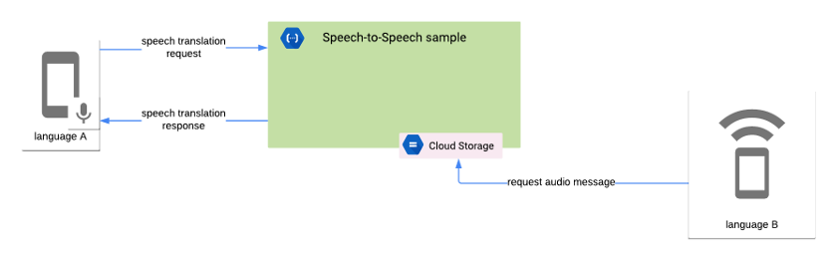The following diagram shows the interaction between the micro service and the client app:

The micro service performs the following tasks:

1. Receives the audio message in the Base64 encoded format.
2. Transcribes the audio message using the Cloud Speech-to-Text API.
3. Translates the transcribed message using the Translation API.
4. Converts the translated message to audio using the Text-to-Speech API.
5. Stores the translated audio message in a Cloud Storage bucket.
6. Sends the response back to the client. The response includes the locale of the translated audio message.

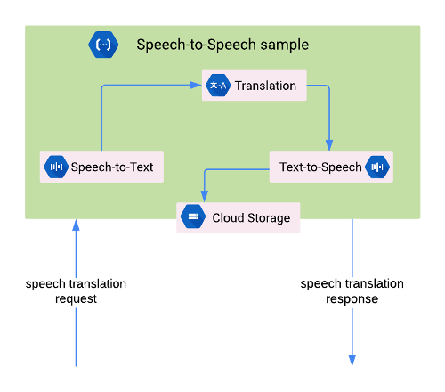

The Android/IOS Framework APIs record audio to provide audio data to the Cloud Speech-to-Text API. It further uses the Cronet Library to upload speech data from the client app to the micro service and to download translated messages from Cloud Storage.

## OPERATIONAL COST CONSIDERATIONS

A brief overview of the factors that contribute to the cost of developing a full-fledged Speech to Speech to translation.

* Firebase defines quotas for Cloud Functions usage that specify resource, time, and rate limits. For more information, see [Quotas and Limits](https://firebase.google.com/docs/functions/quotas) in the Firebase documentation
* Cloud Speech-to-Text API usage is priced monthly based on the length of audio successfully processed. For more information, see [Cloud Speech-to-Text API Pricing](https://cloud.google.com/speech-to-text/pricing).
* Translation API usage is priced monthly based on the amount of characters sent to the API for processing. For more information, see [Translation API Pricing](https://cloud.google.com/translate/pricing).
* Text-to-Speech API usage is priced monthly based on the amount of characters to synthesize into audio. For more information, see [Text-to-Speech API Pricing](https://cloud.google.com/text-to-speech/pricing).
* Firebase Storage usage fees are processed as Google Cloud Storage fees. For more information, see [Cloud Storage Pricing](https://cloud.google.com/storage/pricing).
* Text to Speech services for Arabic are currently not available for Google. For a list of languages supported by Google see [Link](https://cloud.google.com/text-to-speech/docs/voices) Incidentally Google had announced in 2014 that it would never support Arabic (see [link](https://en.wikipedia.org/wiki/Google_Text-to-Speech)). Other solution providers like Microsoft Speech Services, Amazon Polly, and IBM Watson do not support it either.
* To augment for real time features, the app requires a high performance, high-availability, asynchronous real-time messaging platform (Mesibo, as an example) that allows users (endpoints) to communicate with each other in real-time. While this can be achieved using Google Firebase, it does not scale well when the platform reaches a threshold of more than a few 1000 users. In such cases the app will have to piggy back on a third-party messaging platform. Depending on the platform being chosen, their prices for services will vary. Examples are Sendbird, Twilio, Pubnub, Mesibo etc.

*Note:*

* *Based on user testing and analysis on usage and performance, real time messaging platforms may need to be upgraded.*
* *The prices may vary depending on the messaging platforms chosen.*

## USING FIREBASE AS THE BACKBONE

*Cloud Firestore* is a NoSQL JSON data store. Essentially, everything in the *Cloud Firestore* is a JSON object, and each key of this JSON object has its own URL. A sample of our data is represented in the image below.

*Cloud Firestore* [favours a deformalized data structure](https://firebase.google.com/docs/firestore/manage-data/structure-data), so it’s okay to include sender ID and sender Name for each message item. A deformalized data structure means you’ll duplicate a lot of data, but the upside is faster data retrieval.

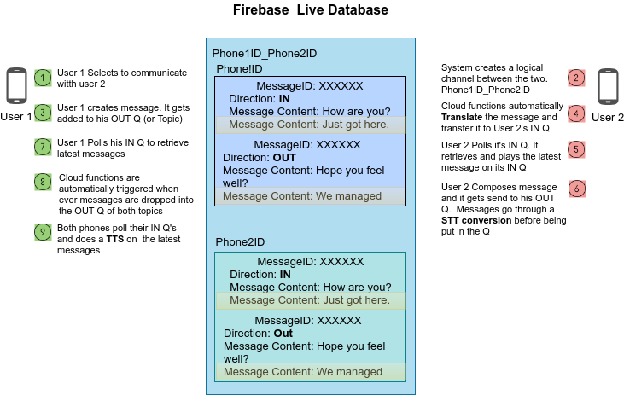

## NON-FUNCTIONAL REQUIREMENTS (OTHERS)

|  |  |
| --- | --- |
| **Requirements** | **Details** |
| User Experience and  UI Design | * The application will be developed only in English * The layout and graphical components will be created considering the usability factors |
| Performance | * Application will allow users to have smooth and quick access to the information or services they require. |
| Security | * Web security standards will be followed. |

## TECHNICAL CONFIGURATIONS

### DEVELOPMENT ENVIRONMENT

* C#/ASP.Net 4.5 / Hybrid Mobile/ Angular/React JS/Node JS
* NO SQL
* HTML / CSS 3
* Google Fire Base and other Google cloud products.

### RECOMMENDED WED HOSTING PACKAGE - DEDICATED

* Operating System: Windows Server
* CPU: 2 cores
* Domains: Unlimited
* Disk Space: 200 GB
* Monthly Bandwidth: 50 GB
* Web site Server Software – IIS 7.5 +
* ASP.NET 4.5
* Hosting will be on cloud according to the band-width.

### BROWSER

The application developed shall be compatible with the browsers listed below:

* Internet Explorer 11
* Mozilla Firefox 50 or above
* Chrome 50 or above

### HARDWARE DEVICES

#### Mobile device with the following specs

* The device should support LTE / Wi-Fi 802.11 a/b/g/n/ac
* The device should have 3 GB RAM and above memory

#### Web Server

We recommend the specification mentioned below for the best output:

* Microsoft Windows Server 2016 with IIS 7.5 +
* Processor: 4.20 GHz Intel Core i7-7700 or equivalent
* Memory: 16GB
* Disk Space: 1 TB of free disk space

### TECHNICAL STANDARDS

* Testing Devices

Google Pixel     Android 7

Motorola Moto G Turbo Edition -   Android 6

* OS Version

Android: Android KitKat and above

IOS: IOS 9+

### TECHNICAL GUIDELINES

These guidelines provide instructions and conditions that will be adhered to during the development of the mobile application.

* API will be used, as the case may be, in realizing the features and functionalities mentioned.
* The client will finalize the functional requirements and UI/UX before the commencement of the project.
* Verbat will be testing the app in the mentioned devices only. Testing on devices other than the ones mentioned under the “Technical Standards “will have to be specified and provided by the client at the beginning of the development phase.
* The client will have to provide the details of the testing devices they are using before the start of development phase.
* Client should provide the relevant Developer's Account credentials before the development phase. In case Verbat needs to create the developer id, additional charges will be incurred by the client.
* The duration mentioned in the project timeline is for the development and testing; any delay or time taken by the review team to respond will not be Verbat’s responsibility.
* Any clarification required from client needs to be addressed within 02 business days.
* The apps will be developed / created within the guidelines of respective play store.
* Verbat will strictly follow the guidelines provided by the respective stores.
* Verbat will inform the client if any of the client requirements / request deviate from it.
* Customization of the features of the app will be susceptible to the limitation imposed by the respective platform/ store.
* Once development commences, the test device/screen sizes will not be susceptible to change. Any change requested by the client will have to go through change management.
* OS version support will be limited to the ones mentioned in the technical specifications. Further support will have to go through change management.

## PROJECT DELIVERY

### PROJECT MANAGEMENT

The Verbat development center strictly follows industry standards on quality. Our project management process is governed by the Verbat Quality Management system and is verified through internal audit programs.

Verbat will dedicate a project leader for the proposed implementation. Furthermore, Verbat proposes the client to identify one project manager (*CSPM – Client-Side Project Manager)* who will be driving all activities undertaken by the client, and will be the single point of contact for Verbat.

### ROLES & RESPONSIBILITIES

Verbat will assign its own dedicated Project Lead (*VPL – Verbat Project Lead*) for the client. The VPL will be responsible for planning and management of all activities related to the project. Furthermore, the VPL will work closely with CSPM, on all periodic status updates and will ensure high level visibility and comfort on the progress of the project.

### DELIVERY ACTIVITY SUMMARY

|  |  |
| --- | --- |
| Activities | Description |
| Proof of Concept | Working Model of the project with two languages. |
| Detailed Requirement Analysis | Verbat team to conduct detailed study of requirement for the phase. If clarification is required, the team will reach out to Client for more information and/or time for discussions. |
| DB Design | DB design for central and test DB. |
| Software Requirement Specification document (SRS) | Once the requirement analysis is completed, Verbat team will submit the SRS document for approval |
| UI/UX Design, Prototyping | Based on the SRS, Verbat UX/UI team will work on the UI/UX of the screens and submit prototype for approval |
| Functional Specification Document (FS) | Once the UI/UX is approved, Verbat shall submit an FS document for approval. |
| Development | Actual system development starts based on the FS. This involves detailed design and software development of Web Application. |
| Testing | Test Planning, test plan creations, internal, integration testing and user acceptance testing. |
| Deployment | Deploying the latest build in the Verbat Test Server. |

### PROJECT IMPLEMENTATION PLAN

Verbat will be providing the solution in a stand-alone fixed bid approach which ensures minimum viable solution for quick wins with core focus on the long-term business objective and outcome. Once the implementation is over, Verbat will initiate the application maintenance process (*once the maintenance contract is signed*) which continues to extend after the implementation.

### DELIVERABLES

* Proof of Concept
* Project Plan
* Software Requirement Specification Document (SRS)
* Prototype Design
* Functional Specification Document (FS)
* Fully Developed & Tested Application
* Source Code

### ESTIMATED DELIVERY TIME

The timeline estimated for delivering the application will be as below:

* working days to complete the proof of concept on completion of resource mobilization.
* working days to complete the SRS & prototype of Language Translation Application.
* working days to complete the development.

| **Activity** |
| --- |
| Contract Signoff (T0) |
| Proof of Concept-Allocate Resource |
| Proof of Concept-Complete |
| Proof of Concept- Approval (T1) |
| Detailed Requirement Gathering |
| Software Requirement Specification Document (SRS) |
| SRS Approval (T2) |
| System UI/UX Prototype-Complete |
| System UI/UX Prototype-Approval (T3) |
| Functional Specification (FS) |
| FS Approval (T4) |
| Development Phase-Complete |
| Perform QC (Unit Testing and Integration Testing) |
| System ready for UAT |
| UAT Acceptance on Verbat production server (T5) |

*Note:*

* *The above-mentioned timeline is in Working Days.*
* *Upon project confirmation, Verbat requires a lead time of minimum () working days for resource mobilization for proof of concept.*
* *Resource mobilization will be initiated post the confirmation of the project along with LPO, signed*

*proposal and advance payment.*

* *The initiation of the UI/UX/Prototype development is dependent on the confirmation of SRS.*
* *The above-mentioned timeline for development is post-confirmation of FS.*
* *Documentation submitted after project initiation and system study supersedes any proposal or documentation submitted during initial requirement gathering / discussion / negotiation.*
* *Project plan will be submitted post the confirmation of project with necessary payments.*
* *Any delay in getting the approvals of deliverables from client will cause change in timelines and the revised timelines will be updated in weekly status reports shared with client after the project commencement.*
* *All approvals and queries regarding the client requirement and any queries which may hinder the project advancement at any stage should be answered by the client within () business days from the time of initiation, failing which, the time delay will get added to the actual effort and timeline estimated.*

### DEPLOYMENT DETAILS

* Cloud server for hosting the application will be the responsibility of the client.
* Verbat will deploy the application on client’s cloud server after the client conducts the necessary acceptance testing.

*Note:*

* *Hosting the application at Verbat’s production server (hosting charges) will call in for additional charges. In the event, client wants to procure SSL, the same can be provided by Verbat at additional cost.*
* *Only deployment of the application will be the responsibility of Verbat, any additional installation will be charged separately.*

### RELEASE PLANNING

* Client will be informed about the release date and time through email.
* Client performs the UAT

### RISK CONTINGENCY PLANNING

Verbat has identified various risk factors associated with this assignment and understands the impact of these risk factors on the project schedules. The objective of this section is to highlight for both Verbat and client, the risk factors, to analyze the impact of the risks on project execution, and to propose strategies to control and reduce the impact of the risk factors. These various risks, which could arise during the project, are tabulated below along with mitigation implementation.

| **Type of risk** | **IMPACT** | Risk Mitigation | Risk Handling |
| --- | --- | --- | --- |
| Scope Creep | **H** | Functions and features will be detailed in system requirement document and will go through client approval. Once this document is approved, all changes will go through the change management process for impact assessment. | Proper change management procedure will be implemented |
| Delay in client feedback | **H** | The plan is prepared with sufficient lead-time for reviews and approvals.  The client will advise us on all dates connected to the document review and approval. | The request for feedback will be escalated if not attended to at the right time so that the schedules are not affected. Deemed acceptance criterion is finalized up-front and will be followed |
| Non-availability of necessary software, frameworks, database instances and infrastructure at client’s hosting environment (If hosting support is provided by Verbat) | **M** | Client will be informed in advance on these requirements. | Possible impact to schedule |
| Manpower attrition | **L** | All efforts will be made to ensure that all initiatives are process dependent. To mitigate risk Verbat/Client will train a person to ensure all back-ups are in place. | A new person will be appointed as early as possible, provided the required project-specific training and mentoring is in place - to minimise impact of attrition on the project |

*H-High, M-Medium, L-Low, NA-Not Applicable*

## PROJECT ASSUMPTIONS

The project solution and technology are created from the initial understanding of the requirement shared with Verbat through mails and meetings. The proposed solution is based on the following assumptions:

### OBJECTIVES

* The requirement is to develop a Language Translation Application (web, android, iOS) with the functionalities as defined in ‘Functional Requirements’ section

### DESIGN

* Client to provide Verbat with the brand guidelines.
* Color theme shall be provided by the client.
* Client shall provide licensed images and logos in specified size & format.
* Client shall provide the text and associated images for the proposed application. Text should be provided in digital format preferably in MS Word 2013 or above
* Verbat is free to use custom-made template for design, if required.
* The application designed for mobiles will be in portrait mode

### DEVELOPMENT

1

Client shall procure the following services:

* Mesibo Services
* Google Transcribing Services.
* Google Translation Services.
* Application shall be developed as a hybrid application so that it can be deployed on both IOS and Android.
* Additional charges may be incurred for archiving and encryption services (depending on the requirements).
* Peers making use of translation services are likely to experience a latency which is directly proportional to the bandwidth of their network connection.
* Peers making use of translation services may have to converse through an intercom like interface.
* The application requires a fast internet connection for real time communication.

# **OUT OF SCOPE**

With the ever-evolving digital market, the requirement should be clear to both the parties involved, hence the importance of mentioning the out of scope details of the project. Following are considered to be out of scope while creating this proposal:

* Purchase of images, fonts
* Any language other than English
* Migration of existing data / Database migration
* Content writing / proof reading / Data Replication / Manual data entry
* Content or image procurement or uploading or editing
* Native iOS App Development / Android App development
* Developer account creation and Maintenance (*IOS and Android Store*)
* Adding new features to the application other than mentioned in the functional specifications. Such requests will be handled via change management. For Change management details, please refer to section titled “Change Management” in the Proposal. (*refer page no: 33*)
* Annual Maintenance Contract (*Bug fixing, debugging, enhancements*) – Please refer to section titled “Maintenance and Support”, unless contracted for. (*refer page no: 34*)
* Hosting Infrastructure and Maintenance (*web and email hosting*), unless contracted for.
* Backup solution and Disaster recovery unless contracted for.
* Physical deployment on-site / installation of the application in devices and physical connection, installation of system.
* Integration with third-party, if any, other than mentioned in the functional specifications
* Hardware Integrations / procurement and purchase
* Procurement of SMS gateway / payment gateway / email gateway
* Integration of SMS gateway / payment gateway
* SSL Purchase and installation, if any
* Plugin/template purchases, if any
* API purchases
* OS other than mentioned in the Hardware Interface
* Relevant / related software libraries
* Mobile offline access or operations

# **CHANGE MANAGEMENT**

Any addition which comes out of the project scope, upon and after the launch of the website will be considered as change management. Verbat recommends the following change management procedures for the same:

* Changes will be implemented only after raising a change request.
* Change requests will be studied and an impact analysis will be performed on the existing work flow.
* Upon assessment of the impact, effort estimation will be calculated and raised as an additional requirement.
* The change request will be initiated only after receiving a formal approval from the client for the additional changes raised.
* Changes which are out of scope will be charged @ per man day rate.

Activities for change scheduled

Modules checked in

Unit testing done

Change request accepted

Informed of the Action

Implementation of changes

Modules checked out

Activities planned and scheduled

Effected modules identified

New system released with change request

Changes made & documented

System

Need for change recognized

User submits change request

Evaluate for cost, schedule & effort

Change control authority

yes

No

## MAINTENANCE & SUPPORT

* Maintenance contracts by default are supported as per the basic SLA terms.
* AMC with Basic SLA is charged at % of the total project value. Additional Effort/change management request will be added towards Total Value of the Project to determine the AMC value.
* Maintenance support is limited to providing application support for ensuring the consistency of the look-and-feel, bug fixes and user issues i.e. maintenance and support of the existing features of the application.
* Support does not in any way cover providing technical or other support to the end users or hardware support. The maintenance agreement does not include functionality changes or feature additions which are handled as change requests which will be charged per man day rate. AMC does not include server support, maintenance and application deployment.
* AMC charges will cover Off-Site Support and Debugging. Support includes E-mail, telephone and video conference (if required). In the event, the application is hosted with the client or if it is a client server development; necessary remote desktop connectivity should be provided for carrying out maintenance activities.
* All maintenance support will be executed by Verbat off-site team. In the event of any need for on-site work, all expenses incurred for such trips (flights, accommodation, meals transportation) will be payable to Verbat by client.
* Gap in AMC - In case if the client does not opt an AMC for a year and wants to renew it after that period, % of the AMC amount for the year for which AMC is not taken will also be payable if the client wishes to renew the AMC contract.

|  |  |  |  |  |
| --- | --- | --- | --- | --- |
| **SLA Type** | **Max Response Time** | | **Max Resolution Time** | **Target** |
| Basic | 1 working day | 3 working days | | Request / incident / problem tickets |

*Note:*

* *Time zone applicable as per India Time Zones (3:30 GMT to 12:30 GMT, Monday to Friday)*
* *Please note that the AMC support shall start only after all the necessary sign-offs (AMC Document) to this effect have been given.*
* *It is not mandatory that the client should opt for an AMC. The client will still be supported on an ad-hoc basis on an agreed man-day rate.*
* *AMC Payment Terms: 100% to be paid as advance.*

AMC Option: Client can opt for time and material based Annual Maintenance, the details of which will be shared post the completion of project.

# **TERMS AND CONDITIONS**

## ACCEPTANCE CRITERIA

* UAT (User Acceptance Test) sign off should take place within Days from the first release of the application and the acceptance confirmation needs to be mailed to Verbat failing which Verbat will consider the project as approved by the client.
* Any comments and reasons for rejection need to be documented and the same needs to be sent as an email from the official e-mail id of client to Verbat on or before days from the first release.
* Timeframe for acceptance for any further release will be mutually agreed and finalized between client and Verbat depending on the UAT Comments

## WARRANTY

* Verbat shall provide a bug ﬁx warranty at no additional cost for 30 days from the date of acceptance of the project, for correction of any errors in the developed application that may be attributed to Verbat.
* However, this does not cover modifications by Client, or use of the application on an environment other than the proposed environment, or other circumstances outside Verbat’s reasonable control. In such cases Verbat reserves the right to charge for its services.
* All error corrections will be executed by Verbat offsite team. In the event of any need for on-site work, all expenses incurred for such trips (flights, accommodation, meals, transportation) will be payable to Verbat by Client.

## SOURCE CODE & INTELLECTUAL PROPERTY RIGHTS

* Upon completion of the Project and 100% completion of the payment, the client will have access to the source code except for proprietary codes, developer tools and third-party applications etc.
* The solution offered will be the intellectual property of the client and will be made available to the client on an “unlimited license” basis.
* No person or organization, other than Verbat or any person authorized by Verbat in writing, has permission to modify/change the software solution to be eligible to get continued support from Verbat as per the support terms defined under this document.
* Verbat accepts no liability or damages of any kind arising out of use or non-use of the software delivered. The responsibility of testing of software lies with the client.

## GENERAL TERMS AND CONDITIONS

* Offer Valid for 30 calendar days from the date of submission of the Proposal.
* An average of 20 working days are assumed in a month.
* All the development activities will be carried out from our off-shore development center in India.
* All the documentations will be provided in English.
* Third party components may be used to develop this application.
* The scope of the project is to develop the application as detailed in the scope of the project and mentioned in this proposal. Any changes or additions will have to go through our change management process.
* This proposal is derived and concluded from either the RFQ /RFP/data shared via email / information transferred during an initial requirement analysis meeting / tele-conversation. Verbat reserves the right to change the terms of this proposal if the final terms (including the costing), features & functionalities and timelines are changed during the course of the project. Hence any fees quoted / timeline committed in this proposal may not be considered as final unless agreed upon and signed by both parties.
* Web Application will be best viewed only in the environment mentioned in the section Browser Compatibility.
* Mobile app will be best viewed only in the environment mentioned in the section Hardware Interface.
* All source codes and other project artifacts will adhere to the Verbat document templates and internal coding standards.
* The documents delivered to the client include the ones mentioned under ‘Deliverables’ and these will adhere to Verbat’s internal document standards.
* Acceptance criteria shall be based on the clauses which were mutually discussed between Verbat and client at the Requirement Analysis phase. The same will be documented and approved by both parties through official emails.
* In the event that the Client requires any extension of the proposed acceptance schedule, the associated effort and cost of such extension will be mutually reviewed.
* If the project needs to be put on Hold / Stopped, a minimum notice period of 1 week is required along with the duration of the holding period. Thereafter Verbat will make a final decision based on the request.
* If deployment is done in the client’s server, Verbat will not be held responsible for any performance issues arising due to hardware malfunctions.
* The Client is responsible for all data-backups in case the application is not hosted on the Verbat server.
* All source codes will only be delivered or uploaded on the production server after the due payments are made to Verbat.

## GENERAL ADMINISTRATIVE, TECHNICAL & FUNCTIONAL ASSUMPTIONS

* Detailed system study is required before the start of the project.
* During the requirement gathering phase, authorized personnel from the Client’s side are expected to be available for discussions and finalization of the HLD (High Level Design), before the development commences.
* Type of reports, formats if under the scope of the project, need to be specified by the Client before the project sign off.
* Workflows if under the scope of the project, need to be specified/ confirmed by client before project signoff.
* Verbat assumes that all sign-offs from the Client will be provided within the agreed and specified timeframe.
* Client will provide all the necessary contents, both text and imagery, before starting the project in the format suggested by Verbat (if any).
* The client should provide the relevant information and data, well in advance of the execution of the related activity. Non- availability of this information or data may lead to an interruption of work, which may result in a delay in delivery as well as additional costs to the client.
* The Client should possess a server with the technical specifications recommended by Verbat for the proposed application.
* The Client will be provided with a one-time training (train the trainer) on how to use the application via a video conference (maximum of 4 hours). Additional training requests will be charged at cost to the client.
* Cost of all third-party components to be borne by the client.
* Application will support in three languages which are supported by Google Text to Speech API.

# **FINANCIALS**

## LANGUAGE TRANSLATION APPLICATION

|  |  |  |
| --- | --- | --- |
| Sl. | Description | Amount (USD) |
| 01. |  | XXXX USD |

*Note:*

* *The above cost is exclusive of VAT applicable in UAE*
* *The above cost includes the cost of third-party service of non-translated calls.*
* *The above cost does not include third-party API purchases.*
* *The above estimate is based on the initial understanding of the requirement grounded on the details shared by client via meetings and tele-conversations. If Verbat finds during the requirement gathering phase that the actual requirements uncovered are different form the original, this might affect the estimates provided and Verbat shall exercise rights to renege on the contract. Clarifications/Changes in the scope during system study/ analysis may call in for additional effort and timeline.*
* *For feature additions, please refer section titled “Change Management “.*
* *LPO to be raised in the name of “Verbanet Technologies LLC” for project initiation*

## PAYMENT TERMS

* % of the proof of concept as advance.
* % of proof of concept on delivery of POC
* % of Language Translation Application as advance.
* % of Language Translation Application on completion of:
* SRS
* Prototype
* % on completion of development in UAT release of the Web Application on Verbat server/Mobile build.
* % of Language Translation Application to be paid on UAT Signoff.

*Note:*

* *Payment should be made within 7 days from the date of invoice.*

### MODE OF PAYMENT

Wire transfer to our bank account

|  |  |  |
| --- | --- | --- |
| Particulars | **Option 01** | **Option 02** |
| Bank Name | Commercial Bank of Dubai | Emirates NBD |
| Account Name | Verbanet Technologies LLC | Verbanet Technologies LLC |
| Account Number | 1000305555 | 1011492858201 |
| Swift Code | CBDUAEAD | EBILAEAD |
| IBAN Number | AE840230000001000305555 | AE61 0260 0010 1149 2858 201 |
| Bank Address | Al Qusais Branch, P.O Box 2668, Al Qusais | Mamzar Branch, Dubai |

*Note:*

* *Bank charges incurred during wire transfer to be borne by the client.*
* *Any local taxes / VAT applicable to be borne by the client.*
* *Client invoices will include VAT charges in addition to the application cost.*

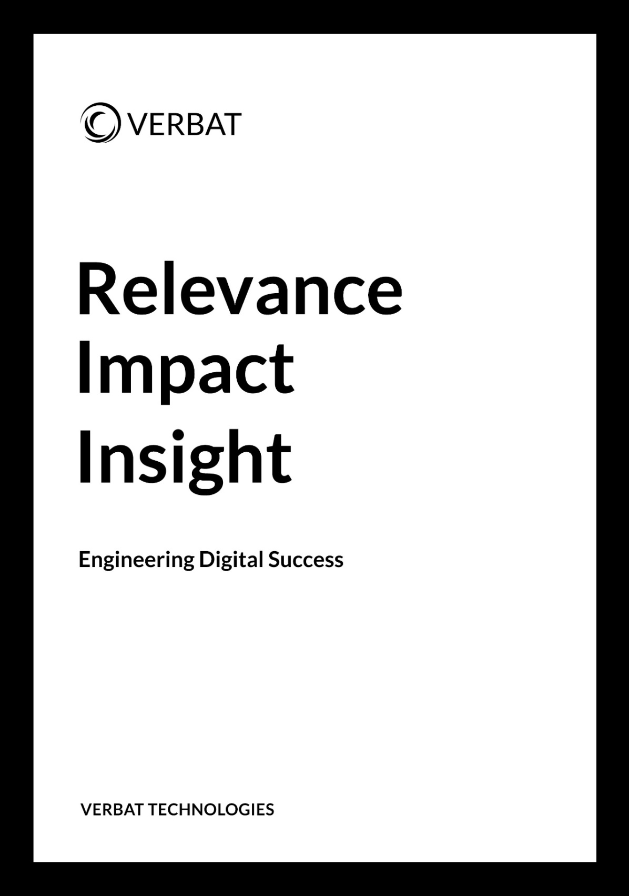

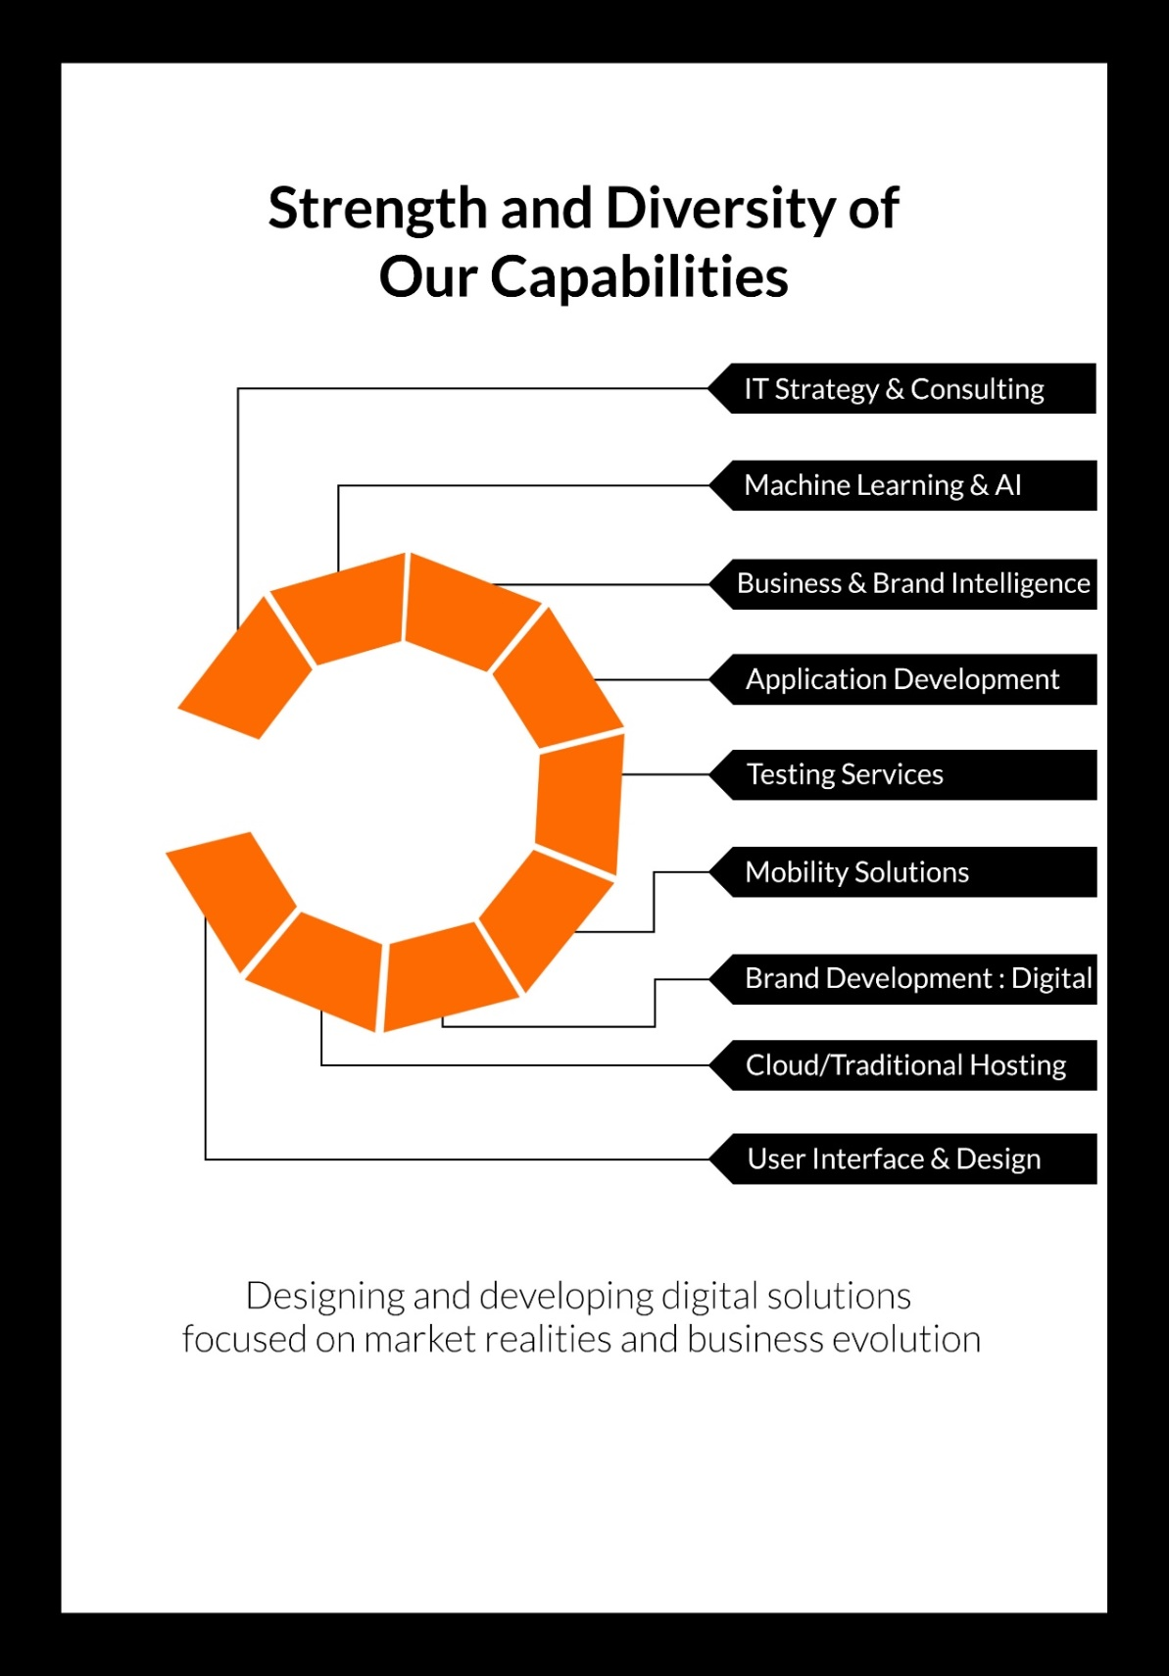

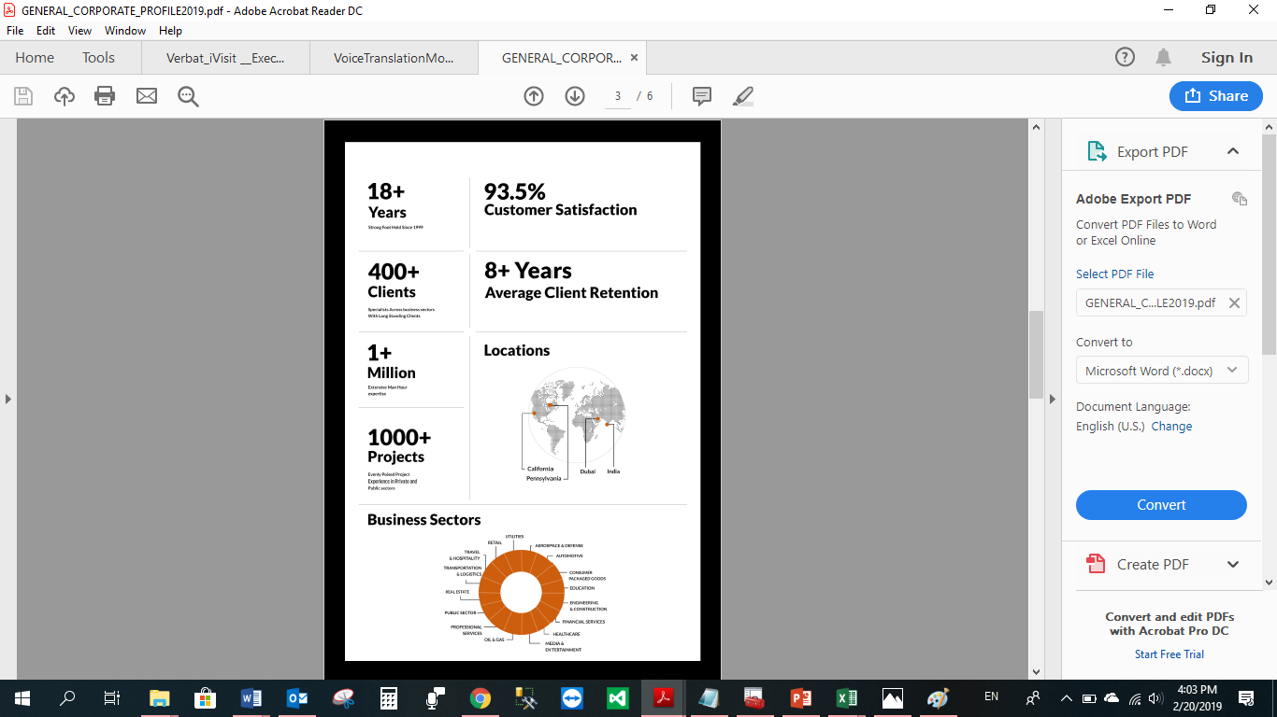

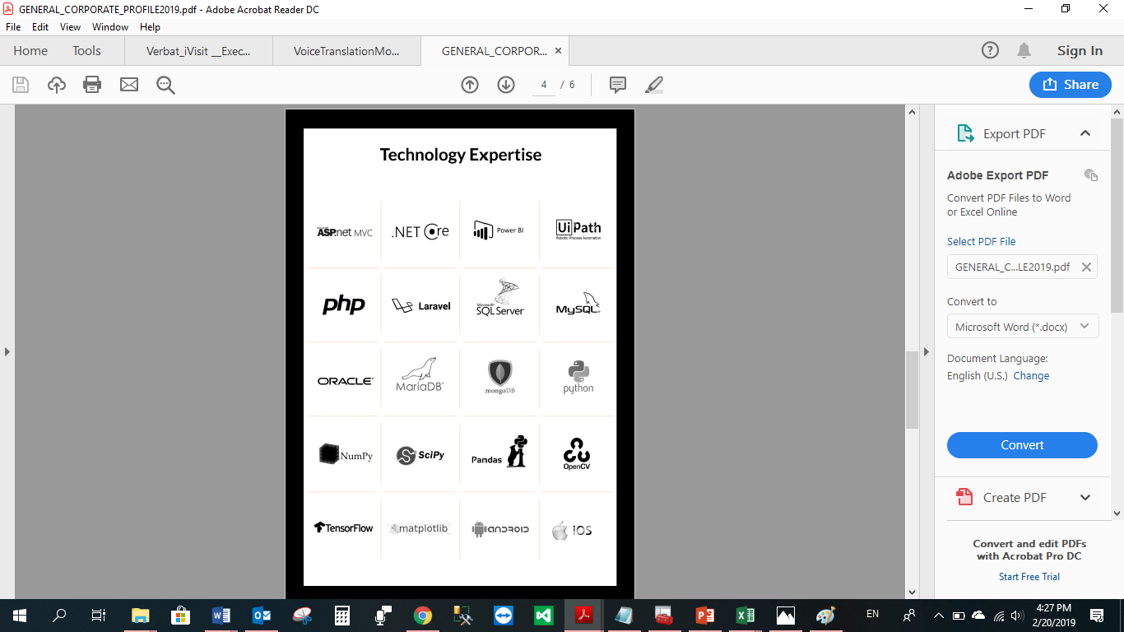

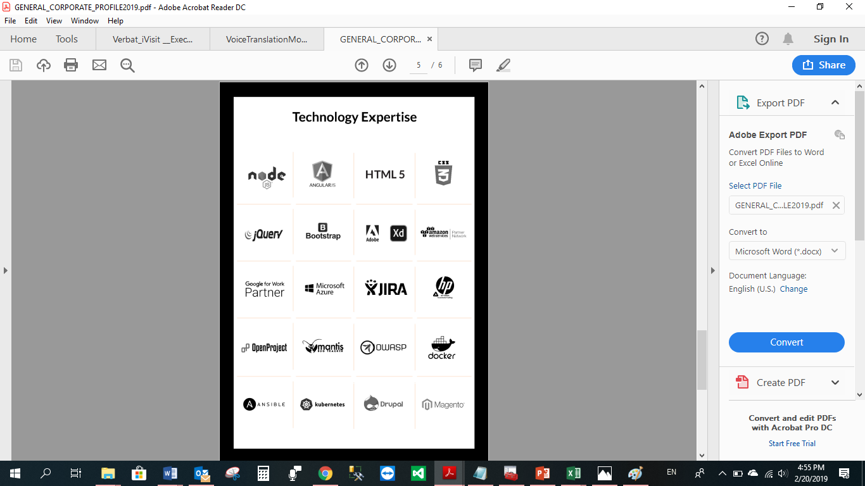

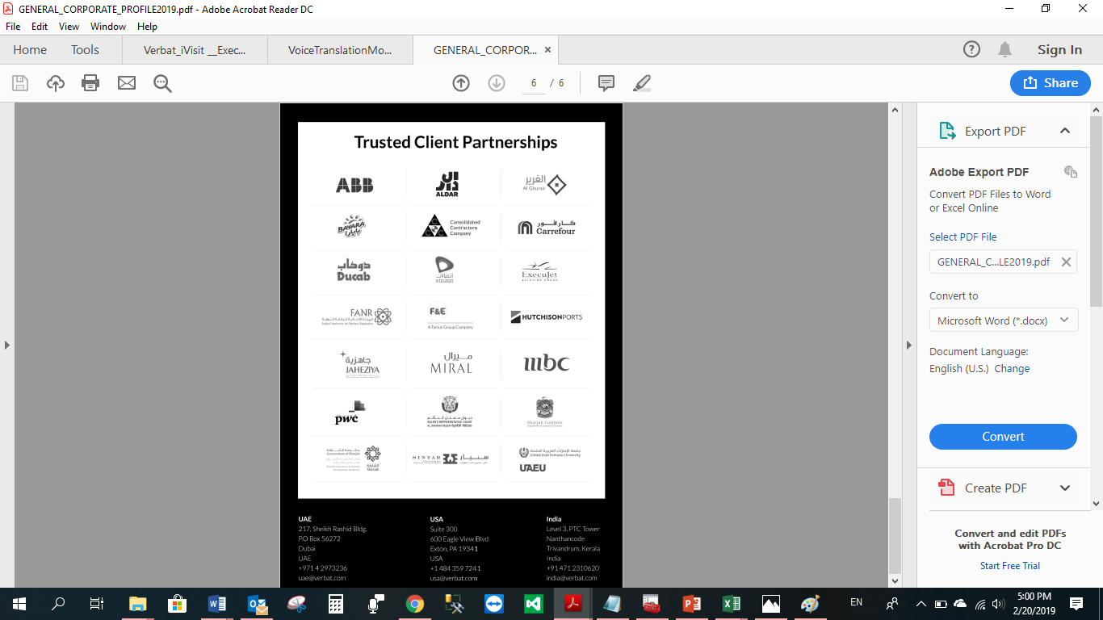

**WITH OUR**

**SINCERE THANKS.**

CONFIDENTIALITY NOTICE:

This Proposal is conﬁdential and contains proprietary information and intellectual property of Verbanet Technologies LLC. Neither this proposal nor any of the information contained herein may be reproduced or disclosed under any circumstances without the express written permission of Verbanet Technologies L.L.C (hereby known under its brand name of Verbat in the United Arab Emirates). 2019. All Rights Reserved.